SFA Midterm

Elizabet Ivanova

*Part I: Hosting a static website on Blob Storage on Azure*

* Creating storage

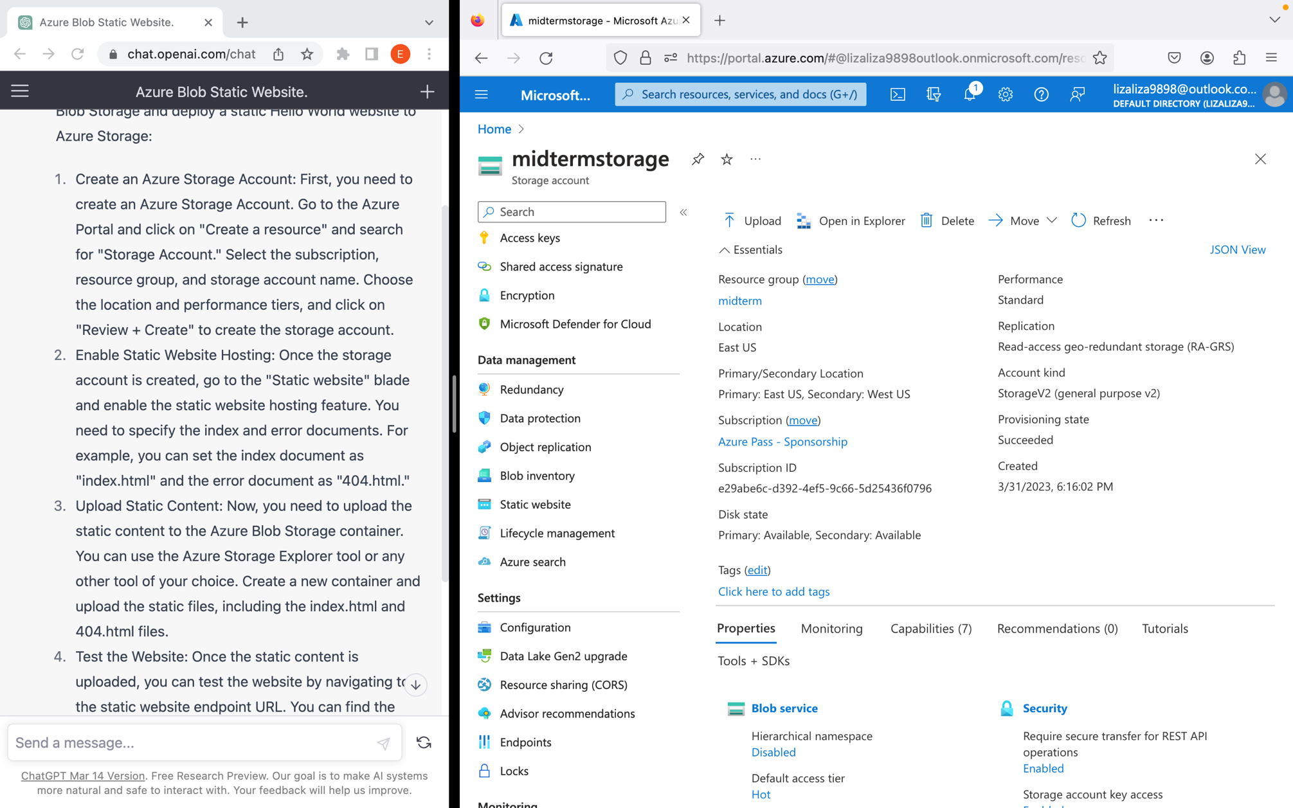

* Enabling static website

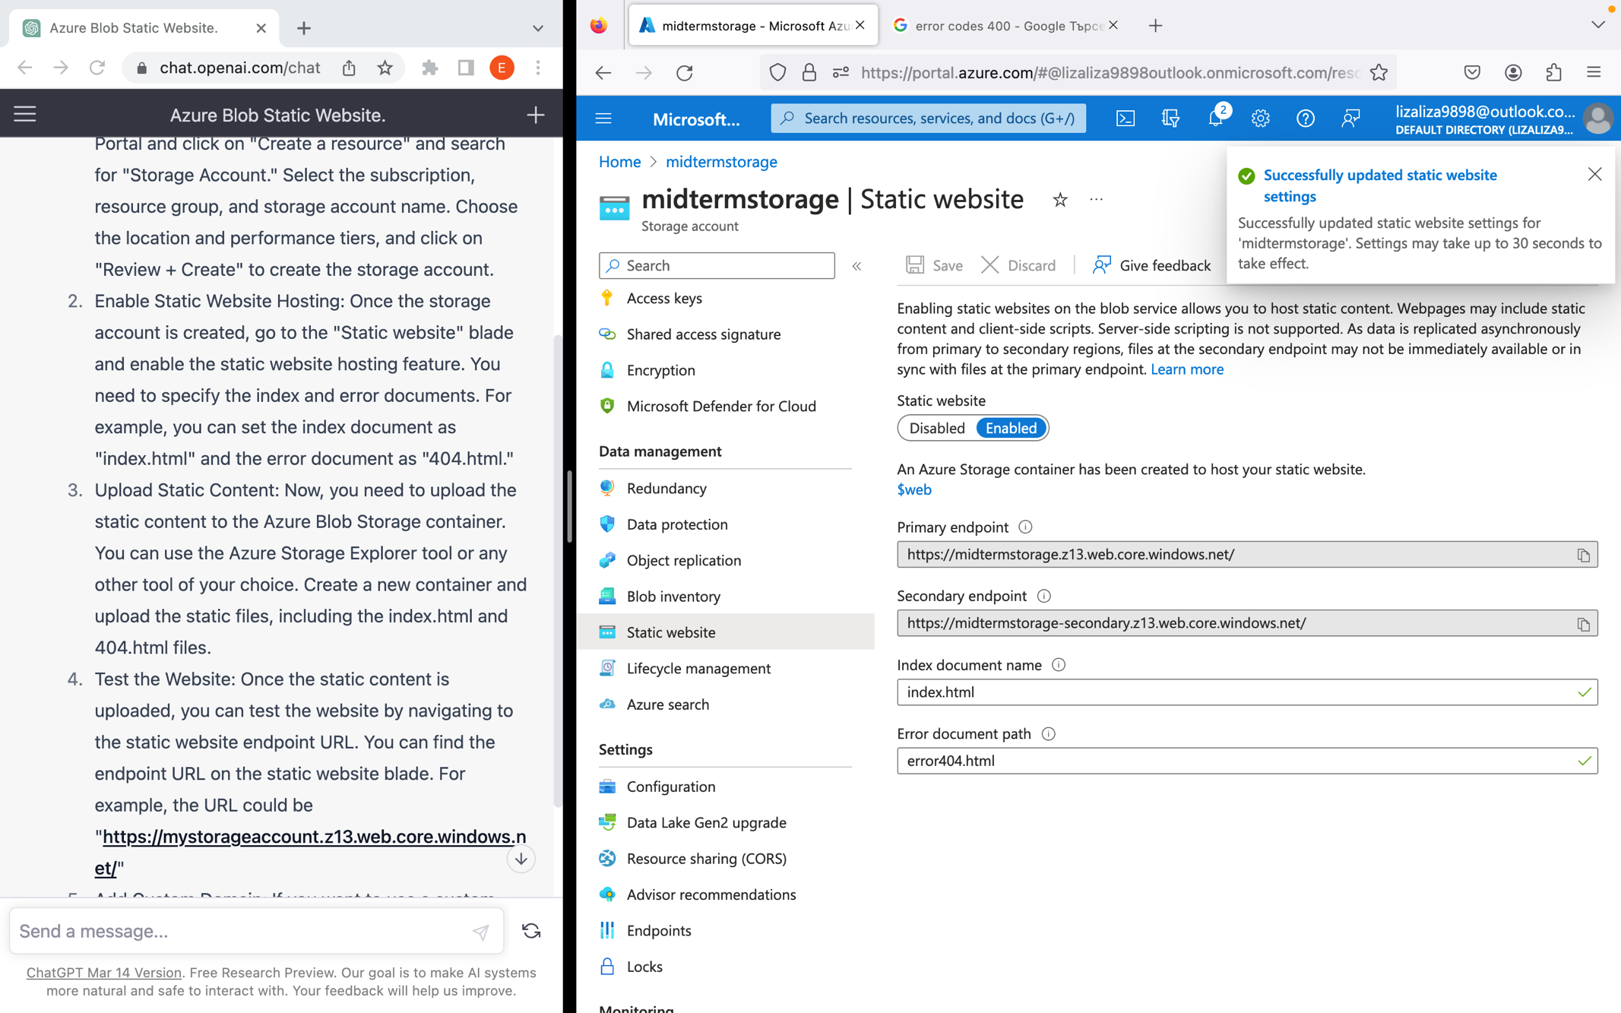

File with “hello world”

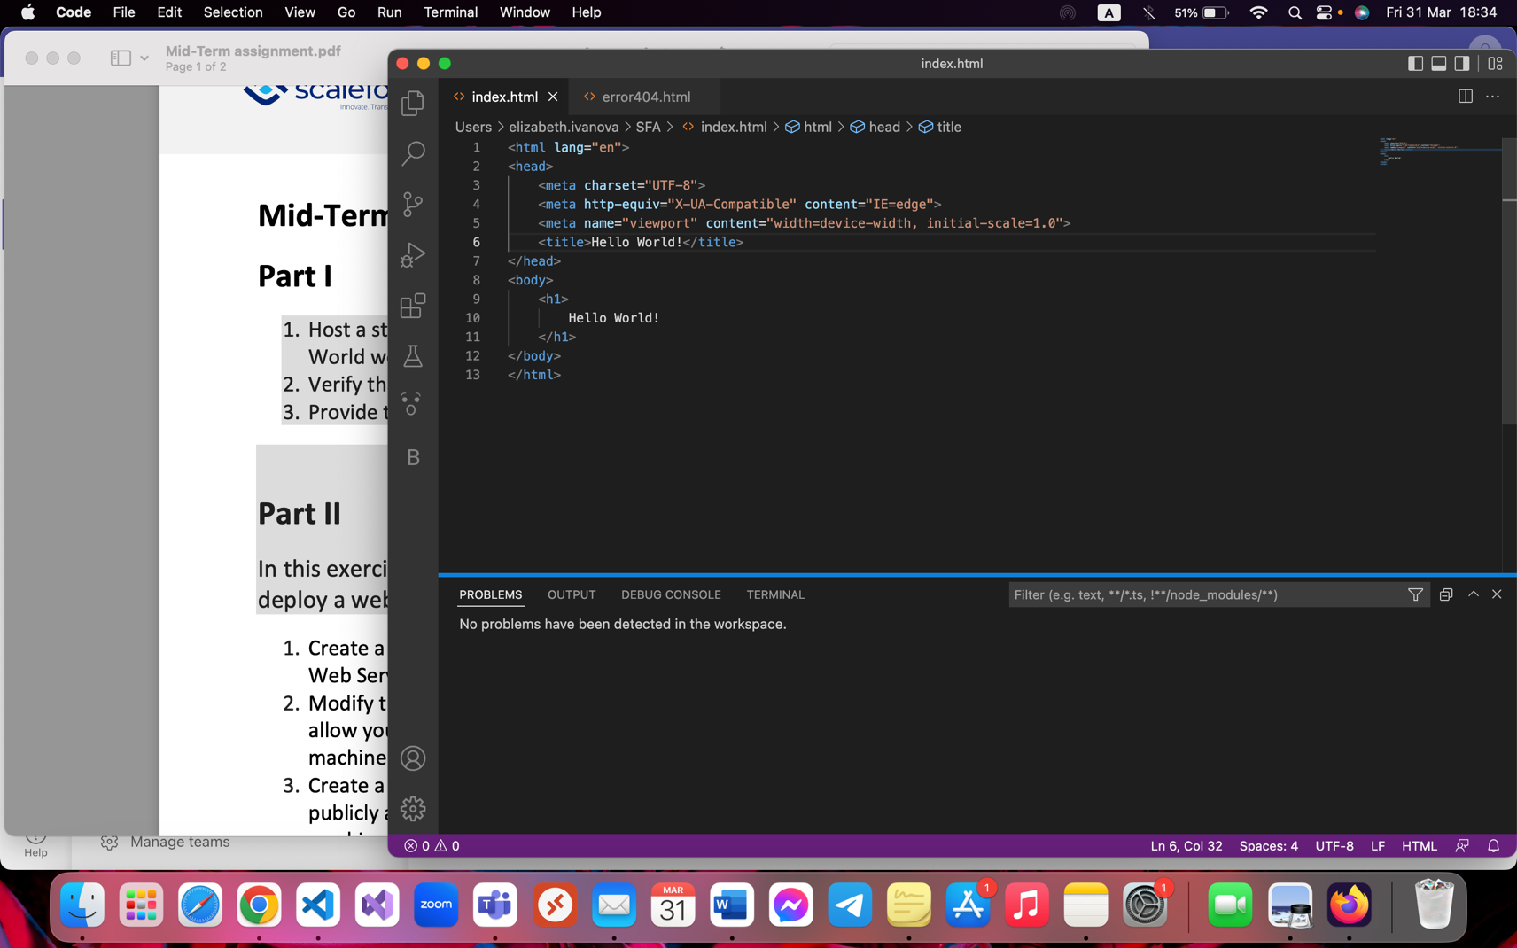

* File form previous screenshot uploaded to blob and is now showing on website

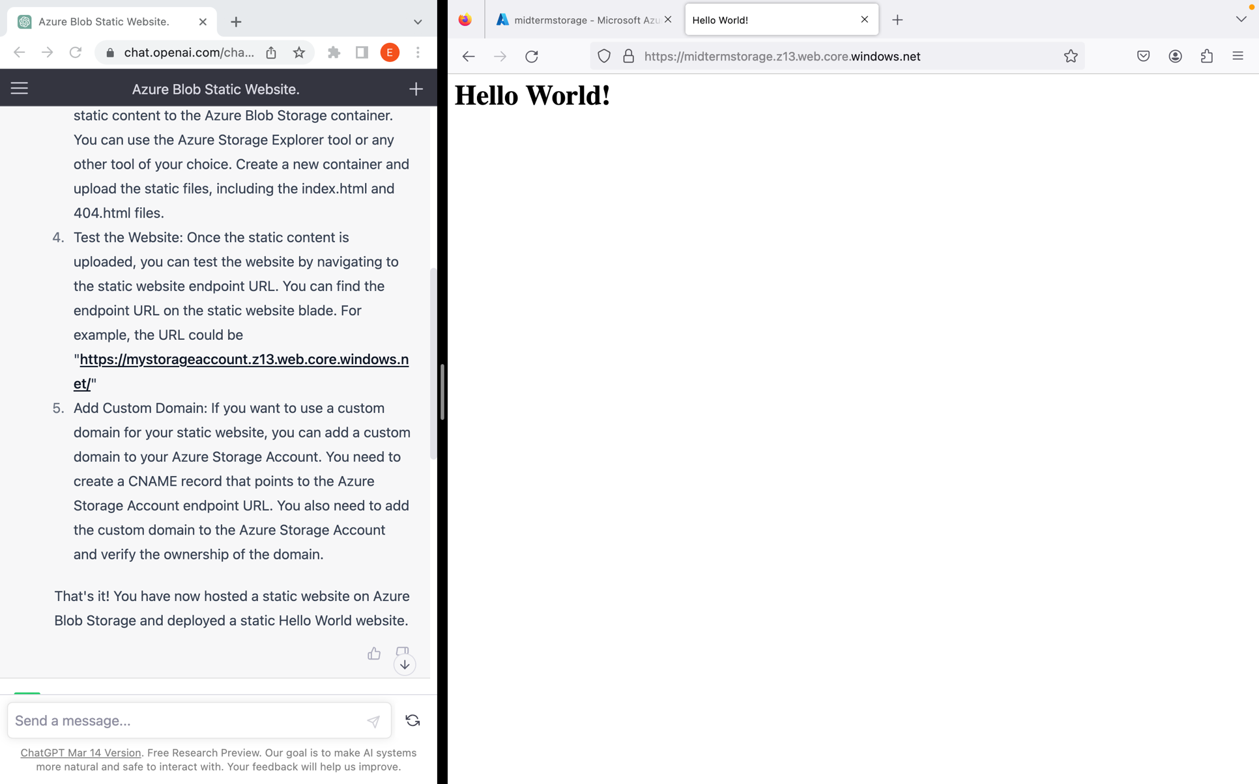

Part 2

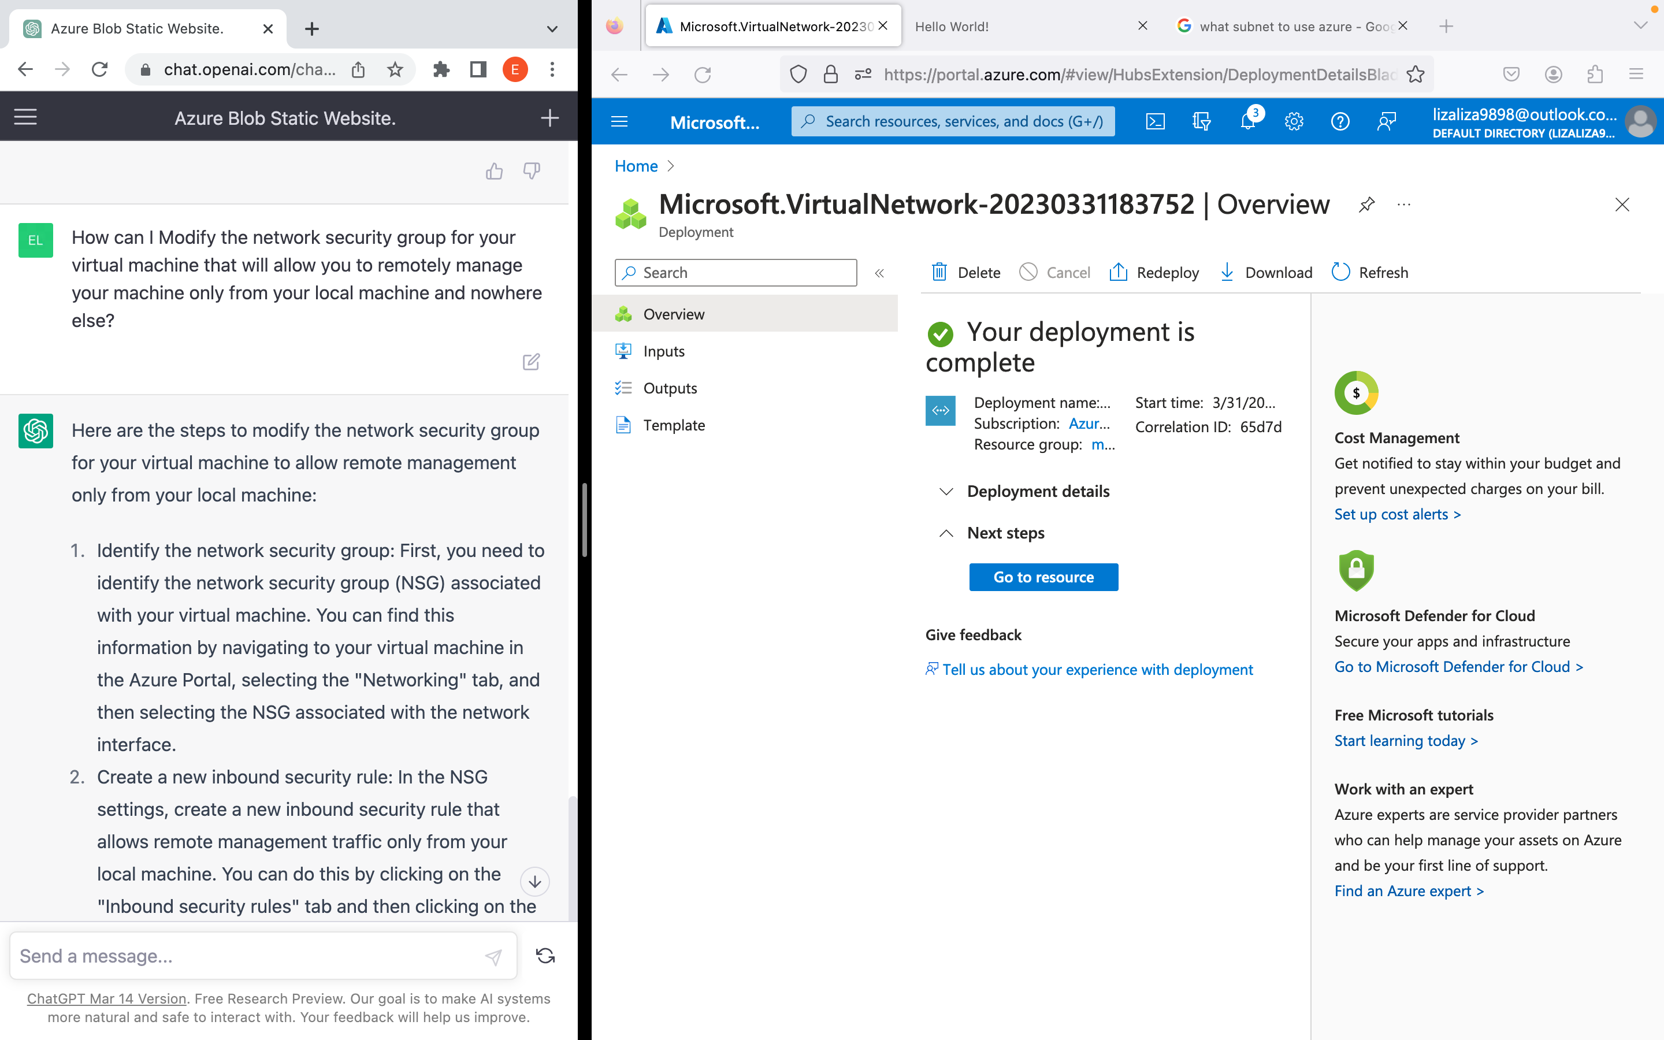-creating vnet

* 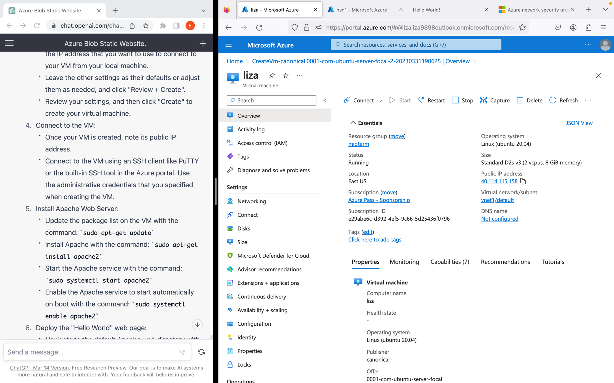VM created in vnet1

* Adding inbound rule only with my IP

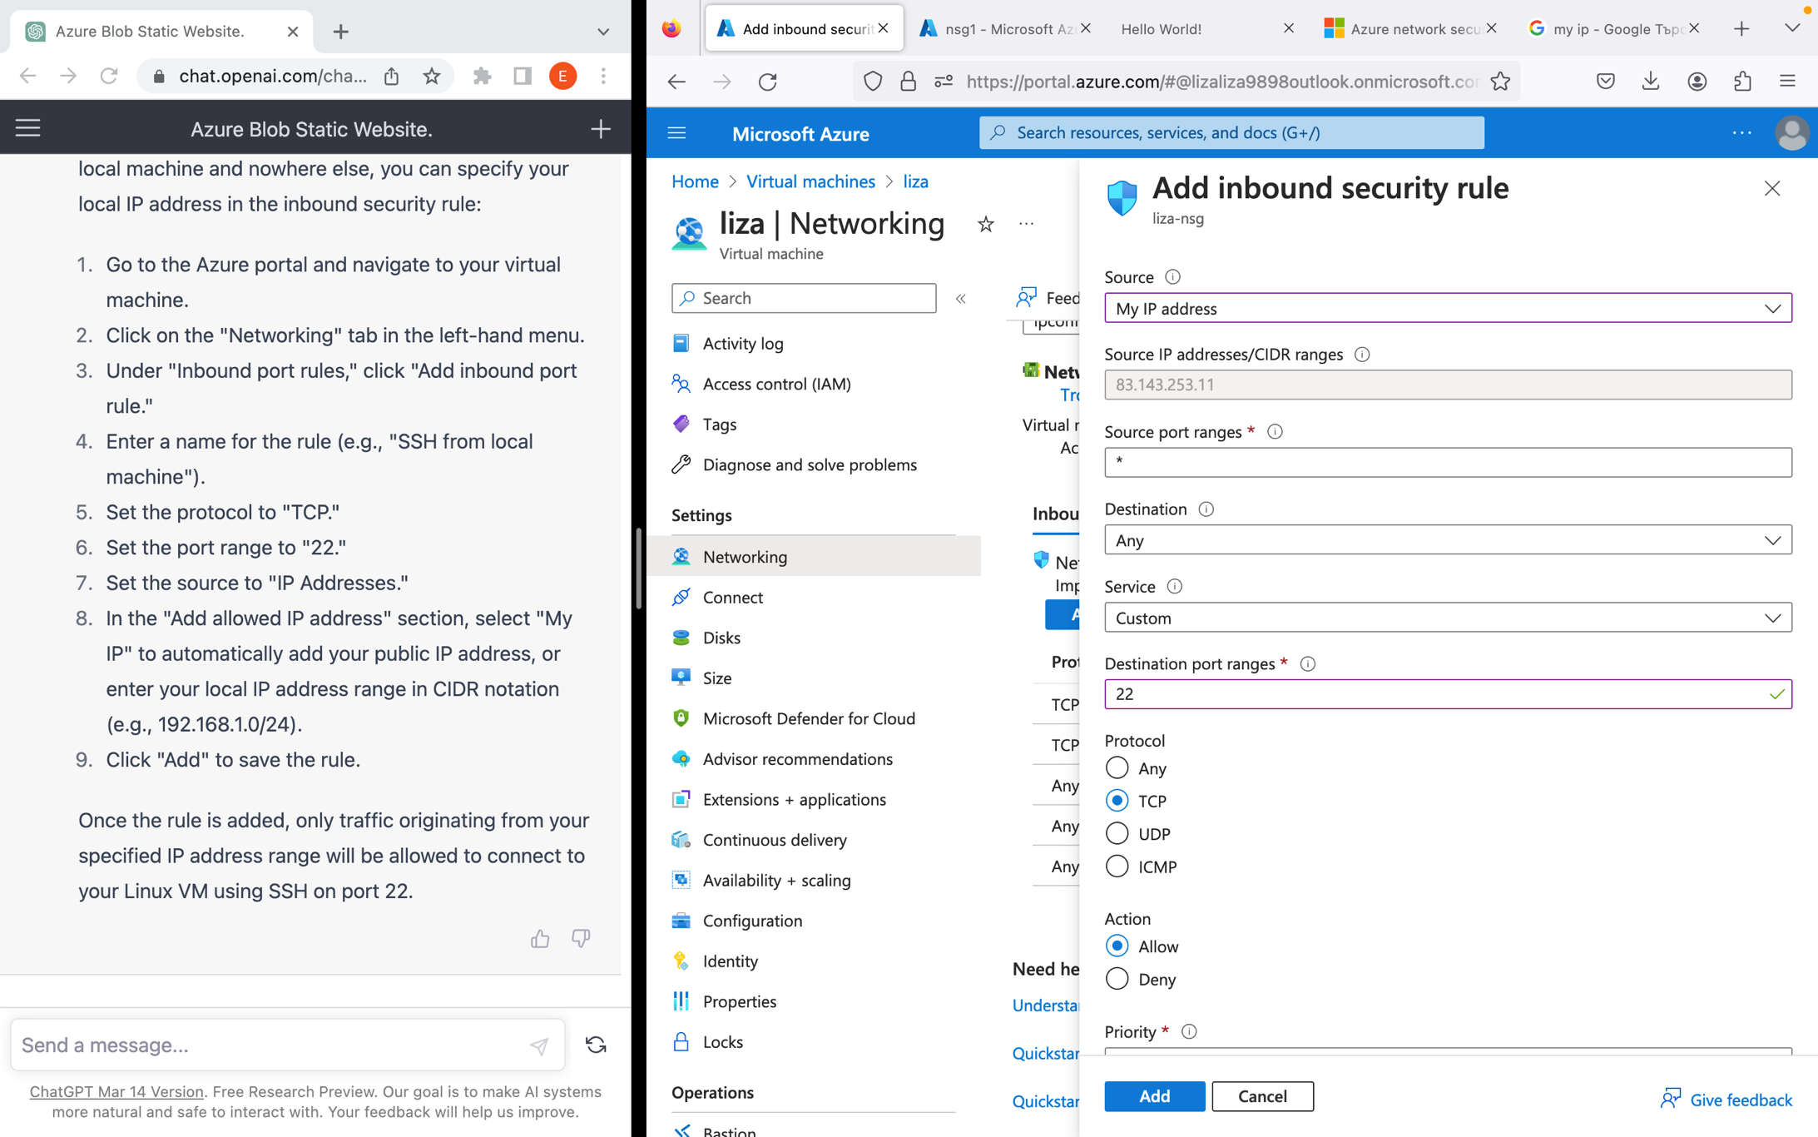

* 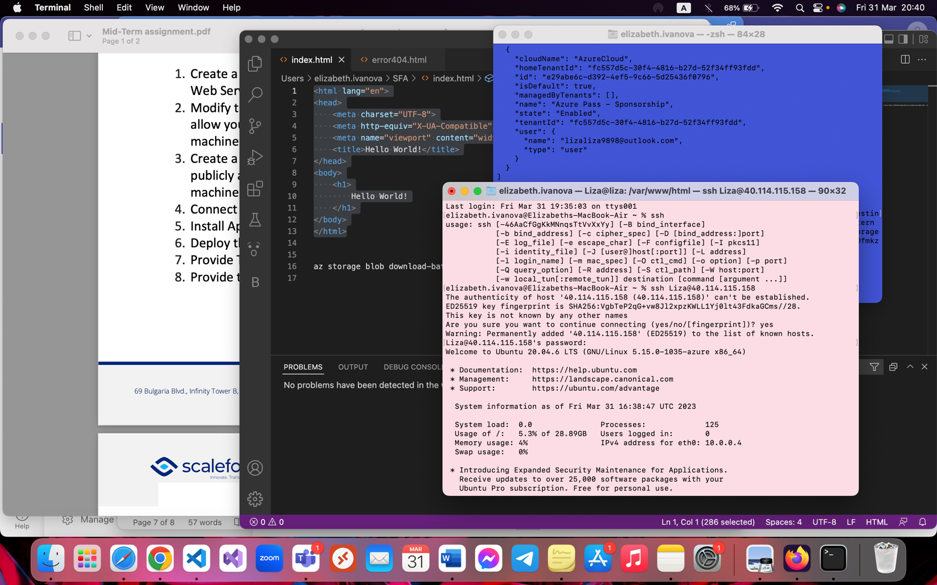connecting to the VM
* Installing and starting apache

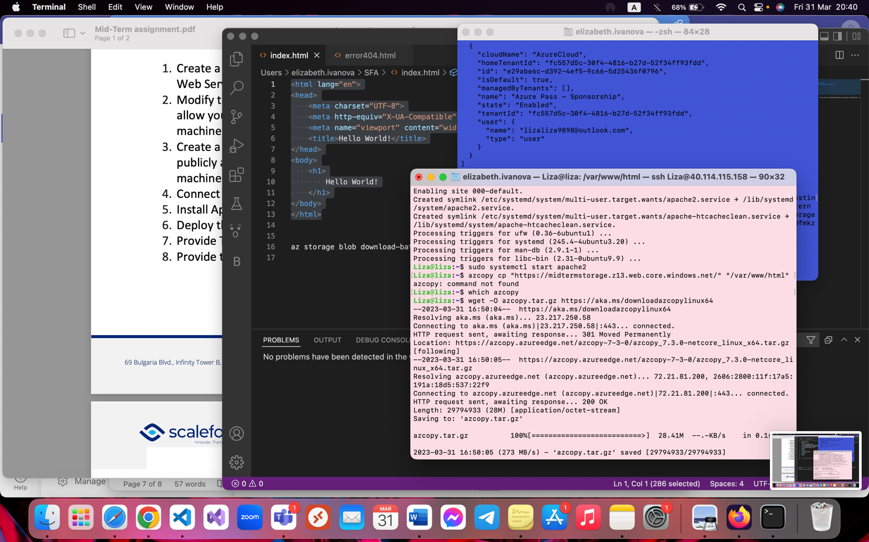

* After that, I had an issue with azcopy. It was missing **libhostfxr.so**

Which is apparently a required thing. So I wasted an hour, actually more, trying to resolve the issue, I tried everything, researched all over the internet, installed Azure CLI on my local machine to try a different approach, tried installing the required thing manually… I tried many things but I kept getting this error.

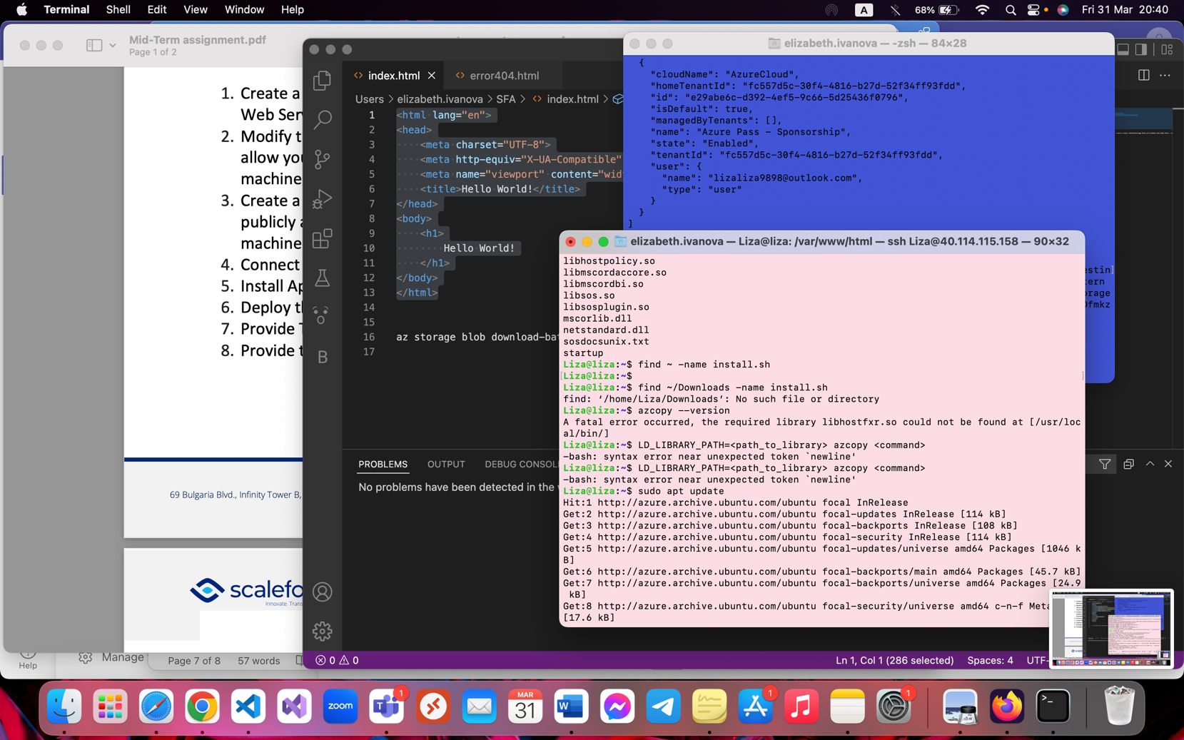

* Here are again some efforts of me trying to solve this issue
* I just couldn’t copy the blob so I simply made another index.html file that would run on the Linux server just to complete the task (even if it would mean using a workaround)

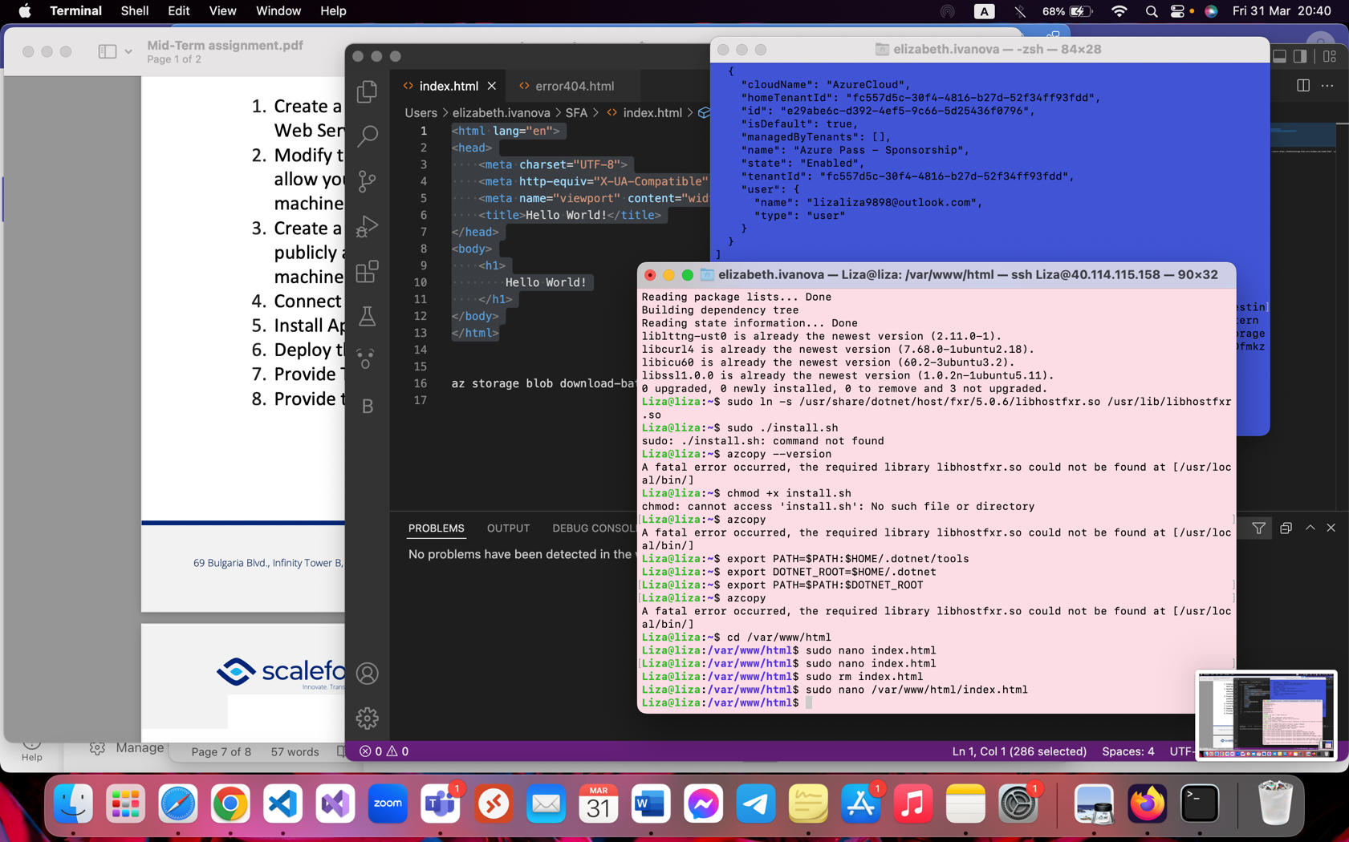

* Phone test: (IP addr same as created VM – can be seen in the previous screenshot it is noted with red)
* Once again, I apologize I could not copy it. I ran into issues I could not resolve but I tried my best for these 3 hours.
* Since the website itself does not have a lot of code, I could use another workaround and just copy/paste the HTML code. With more serious projects, of course it is easier to copy directly from the blob but the problem was entirely from my side so I am sorry.
* The most important thing for me was to submit the completed task.

